ST. JOHN LUTHERAN CHURCH BARTLETT, TX
Order of Service - Sunday, January 29, 2023
Fourth Sunday after Epiphany

Baptism Song - Borning Cry - ELW Hymn #732

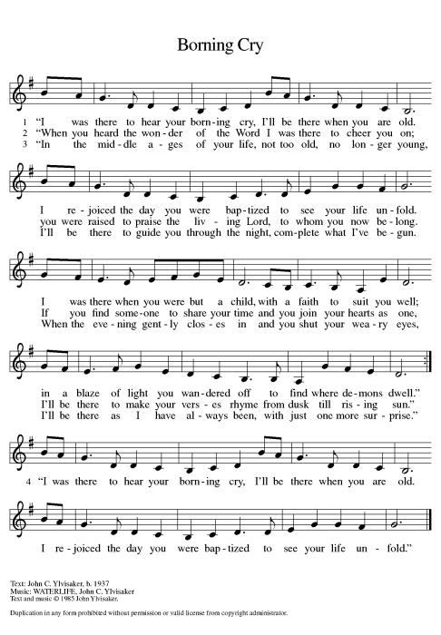

Baptism - Aubrey Mae Bruggman

Pastor: God, who is rich in mercy and love, gives us a new birth into a living hope through the sacrament of baptism. By water and the Word, God delivers us from sin and death and raises us to new life in Jesus Christ. We are united with all the baptized in the one body of Christ, anointed with the gift of the Holy Spirit, and joined in God’s mission for the life of the world.

Parents: We present Aubrey for baptism.

P: Called by the Holy Spirit, trusting in the grace and love of God, do you desire to have him baptized into Christ?

Parents: We do.

P: As you bring Aubrey to receive the gift of baptism, you are entrusted with responsibilities:
to live with her among God’s faithful people,
bring her to the word of God and the holy supper,
teach her the Lord’s Prayer, the Creed, and the Ten Commandments,
place in her hands the holy scriptures,
and nurture her in faith and prayer,
so that Aubrey may learn to trust God,
proclaim Christ through word and deed,
care for others and the world God made,
and work for justice and peace.
P: Do you promise to help Aubrey grow in the Christian faith and life?
Parents: We do.

P: Sponsors, do you promise to nurture Aubrey in the Christian faith as you are empowered by God’s Spirit, and to help her to live in the covenant of baptism and in communion with the church?
Sponsors: We do

Pastor: People of God, do you promise to support Aubrey and pray for her in her new life in Christ?
All: We do.

Pastor: Do you renounce the devil and all the forces that defy God,
the powers of this world that rebel against God,
and the ways of sin that draw you from God?

Parents: We renounce them.

Pastor: Do you believe in God the Father?
All: I believe in God, the Father almighty,
creator of heaven and earth.
Pastor: Do you believe in Jesus Christ, the Son of God?
All: I believe in Jesus Christ, God’s only Son, our Lord,
who was conceived by the Holy Spirit,
born of the virgin Mary,
suffered under Pontius Pilate,
was crucified, died, and was buried;
he descended to the dead.*
On the third day he rose again;
he ascended into heaven,
he is seated at the right hand of the Father,
and he will come to judge the living and the dead.
Pastor: Do you believe in God the Holy Spirit?
All: I believe in the Holy Spirit,
the holy catholic church,
the communion of saints,
the forgiveness of sins,
the resurrection of the body,
and the life everlasting.

*Or, “he descended into hell,” another translation of this text in widespread use.

Pastor: The Lord be with you.
All: And also with you.
Pastor: Let us give thanks to the Lord our God.
All: It is right to give our thanks and praise.
Pastor: We give you thanks, O God, for in the beginning your Spirit moved over the waters and by your Word you created the world, calling forth life in which you took delight. Through the waters of the flood you delivered Noah and his family, and through the sea you led your people Israel from slavery into freedom. At the river your Son was baptized by John and anointed with the Holy Spirit. By the baptism of Jesus’ death and resurrection you set us free from the power of sin and death and raise us up to live in you.

Pour out your Holy Spirit, the power of your living Word, that those who are washed in the waters of baptism may be given new life. To you be given honor and praise through Jesus Christ our Lord, in the unity of the Holy Spirit, now and forever.

All: Amen.

Pastor: Aubrey Mae Bruggman, I baptize you in the name of the Father,
and of the Son,
and of the Holy Spirit.

Pastor: Let us pray.
We give you thanks, O God,
that through water and the Holy Spirit
you give your daughters and sons new birth,
cleanse them from sin, and raise them to eternal life.

P: Sustain Aubrey with the gift of your Holy Spirit:
the spirit of wisdom and understanding,
the spirit of counsel and might,
the spirit of knowledge and the fear of the Lord,
the spirit of joy in your presence, both now and forever.

All: Amen.

Pastor: Aubrey, child of God, you have been sealed by the Holy Spirit and marked with the cross of Christ forever.
All: Amen.

Let us welcome the newly baptized.
All: We welcome you into the body of Christ
and into the mission we share:
join us in giving thanks and praise to God
and bearing God’s creative and redeeming word
to all the world.

Song - O Morning Star, How Fair and Bright - ELW Hymn #308
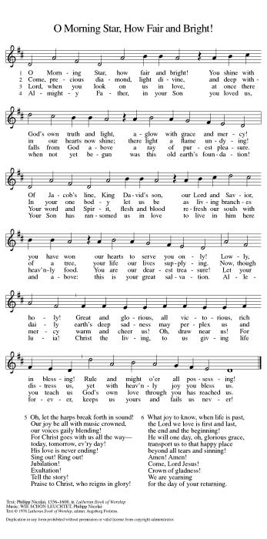

First Reading: Micah 6:1-8
A reading from Micah.
With the mountains and the foundations of the earth as the jury, God brings a lawsuit against Israel. God has “wearied” Israel with a long history of saving acts. God does not want or expect lavish sacrifices to attempt to earn divine favor. Rather God empowers the people to do justice, to love loyalty to God, and to walk shrewdly in God’s service.
¹Hear what the Lord says:
Rise, plead your case before the mountains,
and let the hills hear your voice.
²Hear, you mountains, the controversy of the Lord,
and you enduring foundations of the earth;
for the Lord has a controversy with his people,
and he will contend with Israel.

³“O my people, what have I done to you?
In what have I wearied you? Answer me!
⁴For I brought you up from the land of Egypt,
and redeemed you from the house of slavery;
and I sent before you Moses,
Aaron, and Miriam.
⁵O my people, remember now what King Balak of Moab devised,
what Balaam son of Beor answered him,
and what happened from Shittim to Gilgal,
that you may know the saving acts of the Lord.”

⁶“With what shall I come before the Lord,
and bow myself before God on high?
Shall I come before him with burnt offerings,
with calves a year old?
⁷Will the Lord be pleased with thousands of rams,
with ten thousands of rivers of oil?
Shall I give my firstborn for my transgression,
the fruit of my body for the sin of my soul?”
⁸He has told you, O mortal, what is good;
and what does the Lord require of you
but to do justice, and to love kindness,
and to walk humbly with your God?

The word of the Lord.
Thanks be to God.

Psalm: Psalm 15
Refrain: Lord, who may abide upon your holy hill? (Ps. 15:1)
¹Lord, who may dwell in your | tabernacle?
Who may abide upon your | holy hill?
²Those who lead a blameless life and do | what is right,
who speak the truth | from their heart;
Refrain: Lord, who may abide upon your holy hill?
³they do not slander with the tongue, they do no evil | to their friends;
they do not cast discredit up- | on a neighbor.
⁴In their sight the wicked are rejected, but they honor those who | fear the Lord.
They have sworn upon their health and do not take | back their word.
⁵They do not give their money in hope of gain, nor do they take bribes a- | gainst the innocent.
Those who do these things shall never be | overthrown.
Refrain: Lord, who may abide upon your holy hill?

Second Reading: 1 Corinthians 1:18-31
A reading from 1 Corinthians.
According to the world’s standards of power and might, the message of the cross seems stupid and offensive. Yet this word reveals the paradoxical way God has chosen to work power and salvation through weakness, rejection, and suffering. Hence the message of the cross becomes true wisdom and power for believers.
¹⁸The message about the cross is foolishness to those who are perishing, but to us who are being saved it is the power of God. ¹⁹For it is written,
“I will destroy the wisdom of the wise,
and the discernment of the discerning I will thwart.”
²⁰Where is the one who is wise? Where is the scribe? Where is the debater of this age? Has not God made foolish the wisdom of the world? ²¹For since, in the wisdom of God, the world did not know God through wisdom, God decided, through the foolishness of our proclamation, to save those who believe. ²²For Jews demand signs and Greeks desire wisdom, ²³but we proclaim Christ crucified, a stumbling block to Jews and foolishness to Gentiles, ²⁴but to those who are the called, both Jews and Greeks, Christ the power of God and the wisdom of God. ²⁵For God’s foolishness is wiser than human wisdom, and God’s weakness is stronger than human strength.
²⁶Consider your own call, brothers and sisters: not many of you were wise by human standards, not many were powerful, not many were of noble birth. ²⁷But God chose what is foolish in the world to shame the wise; God chose what is weak in the world to shame the strong; ²⁸God chose what is low and despised in the world, things that are not, to reduce to nothing things that are, ²⁹so that no one might boast in the presence of God. ³⁰He is the source of your life in Christ Jesus, who became for us wisdom from God, and righteousness and sanctification and redemption, ³¹in order that, as it is written, “Let the one who boasts, boast in the Lord.”

The word of the Lord.
Thanks be to God.

Gospel Acclamation (ELW p. 151)
Alleluia. Lord, to whom shall we go?
You have the words of eternal life.
Alleluia.

Gospel: Matthew 5:1-12
The holy gospel according to Matthew.
Glory to you, O Lord.
Jesus opens the Sermon on the Mount by naming those who are blessed in the reign of God.
¹When Jesus saw the crowds, he went up the mountain; and after he sat down, his disciples came to him. ²Then he began to speak, and taught them, saying:
³“Blessed are the poor in spirit, for theirs is the kingdom of heaven.
⁴“Blessed are those who mourn, for they will be comforted.
⁵“Blessed are the meek, for they will inherit the earth.
⁶“Blessed are those who hunger and thirst for righteousness, for they will be filled.
⁷“Blessed are the merciful, for they will receive mercy.
⁸“Blessed are the pure in heart, for they will see God.
⁹“Blessed are the peacemakers, for they will be called children of God.
¹⁰“Blessed are those who are persecuted for righteousness’ sake, for theirs is the kingdom of heaven.
¹¹“Blessed are you when people revile you and persecute you and utter all kinds of evil against you falsely on my account. ¹²Rejoice and be glad, for your reward is great in heaven, for in the same way they persecuted the prophets who were before you.”

The gospel of the Lord.
Praise to you, O Christ.

Children’s Sermon (ELW p. 151) - Pastor Jeremy Ullrich
Sermon (ELW p. 151) - Pastor Jeremy Ullrich
Hymn of the Day - Alleluia, Song of Gladness - ELW Hymn #318
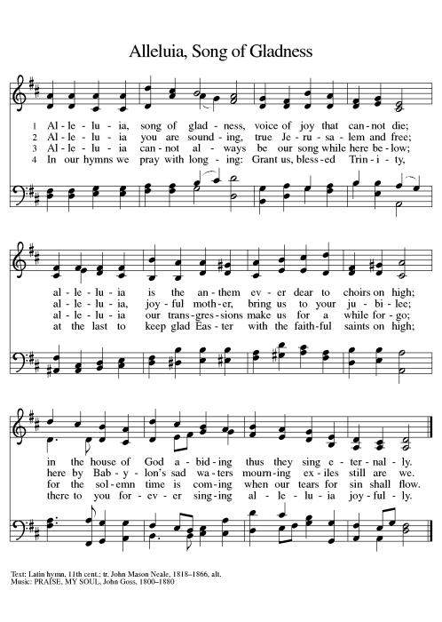

Prayers of Intercession
Called together to follow Jesus, we pray for the church, the world, and all in need.
A brief silence.
Cultivate humility in your church. In gatherings of every size, teach us to boast only in the cross. Shape your church to be people of kindness, generosity, and justice. Merciful God,
receive our prayer.
The foundations of the earth bear witness to your faithfulness; the mountains and hills echo with your holiness. When we mistreat your creation, show us the error of our ways. Inspire us with reverent awe to honor all you have made. Merciful God,
receive our prayer.
You make foolish the wisdom of the world. Raise up honorable leaders who seek justice, love mercy, and pursue peace. Frustrate plans that are corrupt, wicked, and self-seeking. Prosper the work of peacemakers (local and international reconciliation efforts may be named). Merciful God,
receive our prayer.
Bless all whom the world rejects. Accompany those who are regarded as foolish, weak, low, and despised; reveal your power and presence at work where it is least expected. Give your life, strength, and wisdom to all in need (especially). Merciful God,
receive our prayer.
As with your people Israel, remind this congregation of your saving acts. Remind us how your faithfulness brought us through difficulties and sustained us despite our weaknesses. Establish the cross as the center of our life together. Merciful God,
receive our prayer.
Praise to you for your blessed saints in every time and place (especially). Trusting you accompanied them in poverty, persecution, and in every trial, we trust you abide with your people always. Merciful God,
receive our prayer.
We bring to you our needs and hopes, O God, trusting your wisdom and power revealed in Christ crucified.
Amen.

Peace (ELW p. 152)
The peace of Christ be with you always.
And also with you.

Offering (ELW p. 152)

Let the vineyards be fruitful, Lord,
and fill to the brim our cup of blessing.
Gather a harvest from the seeds that were sown,
that we may be fed with the bread of life.
Gather the hopes and the dreams of all;
unite them with the prayers we offer now.
Grace our table with your presence,
and give us a foretaste of the feast to come.

Offering Prayer (ELW p. 152)
Let us pray.
Holy One, we thank you for the healing that springs forth abundantly from this table. Renew our strength to do justice, love kindness, and journey humbly with you. Amen.

Dialogue (ELW p. 152)
The Lord be with you.
And also with you.
Lift up your hearts.
We lift them to the Lord.
Let us give thanks to the Lord our God.
It is right to give our thanks and praise.

Preface (ELW p. 153)
It is indeed right, our duty and our joy,
that we should at all times and in all places
give thanks and praise to you, almighty and merciful God,
through our Savior Jesus Christ.
By the leading of a star he was shown forth to all nations;
In the waters of the Jordan you proclaimed him your beloved Son,
And in the miracle of water turned to wine he revealed your glory.
And so, with all the choirs of angels,
with the church on earth and the hosts of heaven,
we praise your name and join their unending hymn:

Holy, Holy, Holy (ELW p. 153)

Holy, holy, holy Lord,
Lord God of pow’r and might:
Heav’n and earth are full of your glory.
Hosanna in the highest.
Blessed is he who comes in the name of the Lord.
Hosanna in the highest.

Words of Institution (ELW p. 153)
Holy One, the beginning and the end, the giver of life:
Blessed are you for the birth of creation.
Blessed are you in the darkness and in the light.
Blessed are you for your promise to your people.
Blessed are you in the prophets’ hopes and dreams.
Blessed are you for Mary’s openness to your will.
Blessed are you for your Son Jesus,
the Word made flesh.

In the night in which he was betrayed,
our Lord Jesus took bread, and gave thanks;
broke it, and gave it to his disciples, saying:
Take and eat; this is my body, given for you.
Do this for the remembrance of me.

Again, after supper, he took the cup, gave thanks,
and gave it for all to drink, saying:
This cup is the new covenant in my blood,
shed for you and for all people for the forgiveness of sin.
Do this for the remembrance of me.

Lord’s Prayer (ELW p. 154)
Lord, remember us in your kingdom and teach us to pray.
Our Father, who art in heaven,
hallowed be thy name,
thy kingdom come,
thy will be done,
on earth as it is in heaven.
Give us this day our daily bread;
and forgive us our trespasses,
as we forgive those
who trespass against us;
and lead us not into temptation,
but deliver us from evil.
For thine is the kingdom,
and the power, and the glory,
forever and ever. Amen.

Invitation to Communion (ELW p. 154)
Taste and see that the Lord is good.

Communion (ELW p. 154)

Lamb of God, you take away the sin of the world;
have mercy on us.
Lamb of God, you take away the sin of the world;
have mercy on us.
Lamb of God, you take away the sin of the world;
grant us peace, grant us peace.

Communion Hymn - O Lord, Now Let Your Servant - ELW Hymn #313
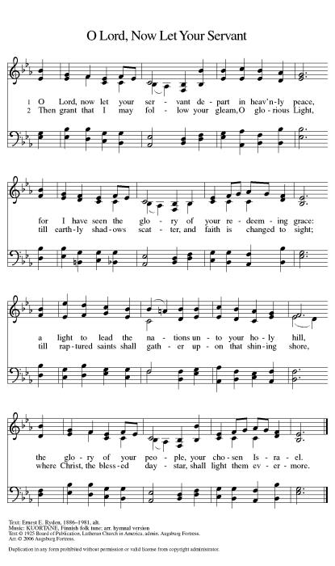

Prayer after Communion (ELW p. 155)
Let us pray.
Holy One, we thank you for the healing that springs forth abundantly from this table. Renew our strength to do justice, love kindness, and journey humbly with you. Amen.

Blessing (ELW p. 155)
The Lord bless you and keep you.
The Lord’s face shine upon you and be gracious unto you.
The Lord look upon you with favor and ☩ give you peace.
Amen.

Closing Hymn - Lord, Dismiss Us with Your Blessing - ELW Hymn #545
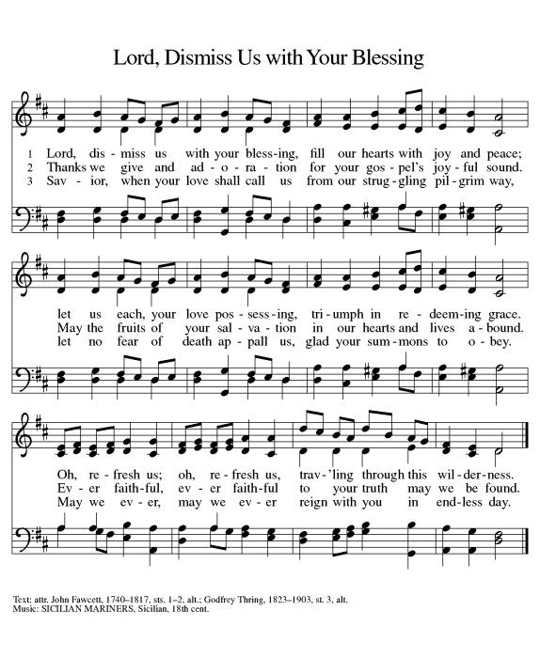

Dismissal (ELW p. 155)
Assistant: Go in peace. Serve the Lord.
Thanks be to God.

From sundaysandseasons.com. Copyright © 2022 Augsburg Fortress. All rights reserved. Hymns available under One License A - 710028.

