ST. JOHN LUTHERAN CHURCH BARTLETT, TX
ELW Holy Communion - Sunday, May 21, 2023
Seventh Sunday of Easter

Announcements
Prelude
Thanksgiving for Baptism (ELW p. 97)
In the name of the Father,
and of the ☩ Son,
and of the Holy Spirit.
Amen.

Joined to Christ in the waters of baptism,
we are clothed with God's mercy and forgiveness.
Let us give thanks for the gift of baptism.

We give you thanks, O God,
for in the beginning your Spirit moved over the waters
and by your Word you created the world,
calling forth life in which you took delight.

Through the waters of the flood you delivered Noah and his family.
Through the sea you led your people Israel from slavery into freedom.
At the river your Son was baptized by John and anointed with the Holy Spirit.
By water and your Word you claim us as daughters and sons,
making us heirs of your promise and servants of all.

We praise you for the gift of water that sustains life,
and above all we praise you for the gift of new life in Jesus Christ.
Shower us with your Spirit,
and renew our lives with your forgiveness, grace, and love.

To you be given honor and praise
through Jesus Christ our Lord
in the unity of the Holy Spirit, now and forever.
Amen.

Gathering Song - Open Now Thy Gates of Beauty - ELW Hymn #533
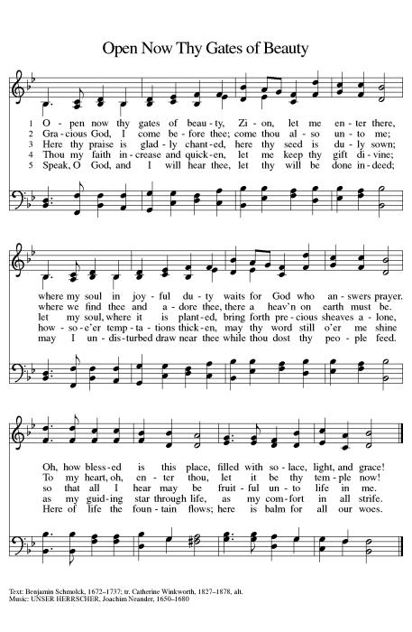
Greeting (ELW p. 147)
The grace of our Lord Jesus Christ, the love of God,
and the communion of the Holy Spirit be with you all.
And also with you.

Kyrie (ELW p. 147)
In peace, let us pray to the Lord.
Lord, have mercy.
For the peace from above,
and for our salvation,
let us pray to the Lord.
Lord, have mercy.
For the peace of the whole world,
for the well-being of the Church of God,
and for the unity of all,
let us pray to the Lord.
Lord, have mercy.
For this holy house,
and for all who offer here their worship and praise,
let us pray to the Lord.
Lord, have mercy.
Help, save, comfort, and defend us, gracious Lord.
Amen.

Canticle of Praise (ELW p. 148)
This is the feast of victory for our God. Alleluia.
Worthy is Christ, the Lamb who was slain,
whose blood set us free to be people of God.
Power and riches and wisdom and strength,
and honor and blessing and glory are his.
This is the feast of victory for our God. Alleluia.
Sing with all the people of God
and join in the hymn of all creation:
Blessing and honor and glory and might
be to God and the Lamb forever. Amen.
This is the feast of victory for our God,
for the Lamb who was slain has begun his reign.
Alleluia. Alleluia.

Prayer of the Day (ELW p. 150)
Let us pray.
A brief silence is kept before the prayer.
O God of glory, your Son Jesus Christ suffered for us and ascended to your right hand. Unite us with Christ and each other in suffering and in joy, that all the world may be drawn into your bountiful presence, through Jesus Christ, our Savior and Lord, who lives and reigns with you and the Holy Spirit, one God, now and forever. Amen.

Song - Let Justice Flow like Streams - ELW Hymn #717
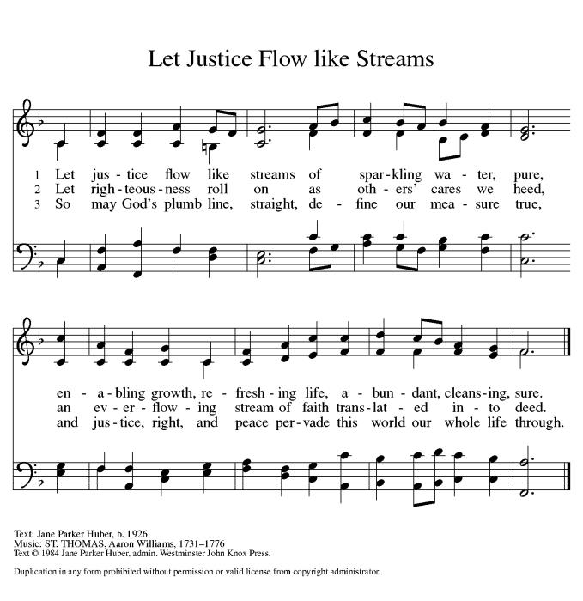
First Reading: Acts 1:6-14
A reading from Acts.
Today’s reading is part of the introduction to the narrative of the outpouring of the Spirit on Pentecost. These verses tell of the risen Lord’s conversation with his disciples on the eve of his ascension, in which he promises that they will receive the power of the Holy Spirit.
⁶When [the apostles] had come together, they asked [Jesus], “Lord, is this the time when you will restore the kingdom to Israel?” ⁷He replied, “It is not for you to know the times or periods that the Father has set by his own authority. ⁸But you will receive power when the Holy Spirit has come upon you; and you will be my witnesses in Jerusalem, in all Judea and Samaria, and to the ends of the earth.” ⁹When he had said this, as they were watching, he was lifted up, and a cloud took him out of their sight. ¹⁰While he was going and they were gazing up toward heaven, suddenly two men in white robes stood by them. ¹¹They said, “Men of Galilee, why do you stand looking up toward heaven? This Jesus, who has been taken up from you into heaven, will come in the same way as you saw him go into heaven.”
¹²Then they returned to Jerusalem from the mount called Olivet, which is near Jerusalem, a sabbath day’s journey away. ¹³When they had entered the city, they went to the room upstairs where they were staying, Peter, and John, and James, and Andrew, Philip and Thomas, Bartholomew and Matthew, James son of Alphaeus, and Simon the Zealot, and Judas son of James. ¹⁴All these were constantly devoting themselves to prayer, together with certain women, including Mary the mother of Jesus, as well as his brothers.

The word of the Lord.
Thanks be to God.

Psalm: Psalm 68:1-10, 32-35
Refrain: Sing to God, who rides upon the clouds. (Ps. 68:4)
¹Let God arise, and let God’s ene- | mies be scattered;
let those who | hate God flee.
²As smoke is driven away, so you should drive | them away;
as the wax melts before the fire, so let the wicked perish at the pres- | ence of God.
³But let the righteous be glad and rejoice | before God;
let them also be mer- | ry and joyful.
⁴Sing to God, sing praises to God’s name; exalt the one who | rides the clouds;
I Am is that name, rejoice | before God!
R: Sing to God, who rides upon the clouds.
⁵In your holy habita- | tion, O God,
you are a father to orphans, defend- | er of widows;
⁶you give the solitary a home and bring forth prisoners | into freedom;
but the rebels shall live in | desert places.
⁷O God, when you went forth be- | fore your people,
when you marched | through the wilderness,
⁸the earth quaked, and the skies poured down rain, at the presence of God, the | God of Sinai,
at the presence of God, the | God of Israel.
⁹You sent a bountiful | rain, O God;
you restored your inheritance | when it languished.
¹⁰Your people found their | home in it;
in your goodness, O God, you have made provision | for the poor.
R: Sing to God, who rides upon the clouds.
³²Sing to God, O kingdoms | of the earth;
sing praises | to the Lord.
³³You ride in the heavens, O God, in the | ancient heavens;
you send forth your voice, your | mighty voice.
³⁴Ascribe pow- | er to God,
whose majesty is over Israel; whose strength is | in the skies.
³⁵How wonderful you are in your holy places, O | God of Israel,
giving strength and power to your people! | Blessed be God!
R: Sing to God, who rides upon the clouds.

Second Reading: 1 Peter 4:12-14; 5:6-11
A reading from 1 Peter.
Our faith in Christ does not make us immune from the scorn of others. Nevertheless, we are to resist the designs of evil when we experience disparagement from others because we trust God’s grace will strengthen and guide us.
¹²Beloved, do not be surprised at the fiery ordeal that is taking place among you to test you, as though something strange were happening to you. ¹³But rejoice insofar as you are sharing Christ’s sufferings, so that you may also be glad and shout for joy when his glory is revealed. ¹⁴If you are reviled for the name of Christ, you are blessed, because the spirit of glory, which is the Spirit of God, is resting on you.
^{5:6}Humble yourselves therefore under the mighty hand of God, so that he may exalt you in due time. ⁷Cast all your anxiety on him, because he cares for you. ⁸Discipline yourselves, keep alert. Like a roaring lion your adversary the devil prowls around, looking for someone to devour. ⁹Resist him, steadfast in your faith, for you know that your brothers and sisters in all the world are undergoing the same kinds of suffering. ¹⁰And after you have suffered for a little while, the God of all grace, who has called you to his eternal glory in Christ, will himself restore, support, strengthen, and establish you. ¹¹To him be the power forever and ever. Amen.

The word of the Lord.
Thanks be to God.

Gospel Acclamation (ELW p. 151)
Alleluia. Lord, to whom shall we go?
You have the words of eternal life.
Alleluia.

Gospel: John 17:1-11
The holy gospel according to John.
Glory to you, O Lord.
On the night before his crucifixion, Jesus prays to his heavenly Father, asking that those who continue his work in this world will live in unity.
¹After Jesus had spoken these words [to his disciples], he looked up to heaven and said, “Father, the hour has come; glorify your Son so that the Son may glorify you, ²since you have given him authority over all people, to give eternal life to all whom you have given him. ³And this is eternal life, that they may know you, the only true God, and Jesus Christ whom you have sent. ⁴I glorified you on earth by finishing the work that you gave me to do. ⁵So now, Father, glorify me in your own presence with the glory that I had in your presence before the world existed.
⁶“I have made your name known to those whom you gave me from the world. They were yours, and you gave them to me, and they have kept your word. ⁷Now they know that everything you have given me is from you; ⁸for the words that you gave to me I have given to them, and they have received them and know in truth that I came from you; and they have believed that you sent me. ⁹I am asking on their behalf; I am not asking on behalf of the world, but on behalf of those whom you gave me, because they are yours. ¹⁰All mine are yours, and yours are mine; and I have been glorified in them. ¹¹And now I am no longer in the world, but they are in the world, and I am coming to you. Holy Father, protect them in your name that you have given me, so that they may be one, as we are one.”

The gospel of the Lord.
Praise to you, O Christ.

Children’s Sermon (ELW p. 151) - Pastor Jeremy Ullrich
Sermon (ELW p. 151) - Pastor Jeremy Ullrich
Hymn of the Day - Come, Thou Fount of Every Blessing - ELW Hymn #807
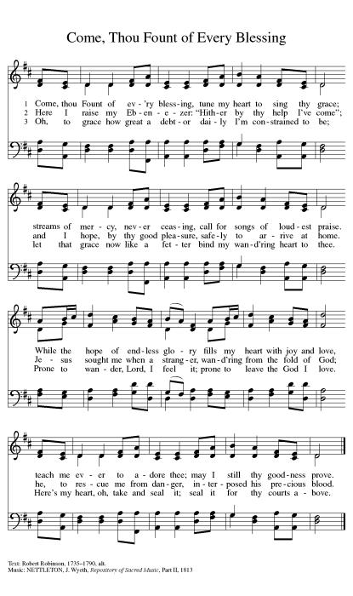
Creed (ELW p. 152)
We believe in one God,
the Father, the Almighty,
maker of heaven and earth,
of all that is, seen and unseen.
We believe in one Lord, Jesus Christ,
the only Son of God,
eternally begotten of the Father,
God from God, Light from Light,
true God from true God,
begotten, not made,
of one Being with the Father;
through him all things were made.
For us and for our salvation
he came down from heaven,
was incarnate of the Holy Spirit and the virgin Mary
and became truly human.
For our sake he was crucified under Pontius Pilate;
he suffered death and was buried.
On the third day he rose again
in accordance with the scriptures;
he ascended into heaven
and is seated at the right hand of the Father.
He will come again in glory to judge the living and the dead,
and his kingdom will have no end.
We believe in the Holy Spirit, the Lord, the giver of life,
who proceeds from the Father and the Son,*
who with the Father and the Son is worshiped and glorified,
who has spoken through the prophets.
We believe in one holy catholic and apostolic church.
We acknowledge one baptism for the forgiveness of sins.
We look for the resurrection of the dead,
and the life of the world to come. Amen.

*Or, “who proceeds from the Father.” The phrase “and the Son” is a later addition to the creed.

Prayers of Intercession
United in the hope and joy of the resurrection, let us pray for the church, the world, and all in need.
A brief silence.
God of harmony, as you drew your son to your side, you draw us to you and unite us with the planet and one another. Weave your church together in a web of mutual love for the sake of the world. Hear us, O God.
Your mercy is great.
As your Spirit hovered over the waters of creation, so your Spirit hovers over all that you have made. Bless the water that sustains the planet and grant wisdom to use it wisely. Hear us, O God.
Your mercy is great.
You empower your people with the fire of your Spirit. Challenge activists and organizers, teachers and politicians, and all in leadership to speak a message of peace and justice. Hear us, O God.
Your mercy is great.
You care for all your children. Show your steadfast love to those suffering isolation, especially exiles, refugees, or prisoners. Break the chains of all held fast by systemic oppression of any kind. Comfort all who are afraid or suffering from illness. Hear us, O God.
Your mercy is great.
We give thanks that humankind serves as your body in the world, stewarding your abundant gifts. Guide this congregation’s leaders as they seek your will. We pray for our staff and council. Hear us, O God.
Your mercy is great.
You raise your saints to new life in Christ. We give you thanks for all your saints who have given us glimpses of your redeeming love. Hear us, O God.
Your mercy is great.
Rejoicing in the victory of Christ’s resurrection, we lift our prayers and praise to you, almighty and eternal God; through Jesus Christ, our risen Lord.
Amen.

Peace (ELW p. 152)
The peace of Christ be with you always.
And also with you.

Offering (ELW p. 152)

Let the vineyards be fruitful, Lord,
and fill to the brim our cup of blessing.
Gather a harvest from the seeds that were sown,
that we may be fed with the bread of life.
Gather the hopes and the dreams of all;
unite them with the prayers we offer now.
Grace our table with your presence,
and give us a foretaste of the feast to come.

Offering Prayer (ELW p. 152)
Let us pray.
Blessed are you, O God, ruler of heaven and earth. Day by day you shower us with blessings. As you have raised us to new life in Christ, give us glad and generous hearts, ready to praise you and to respond to those in need, through Jesus Christ, our Savior and Lord. Amen.

Dialogue (ELW p. 152)
The Lord be with you.
And also with you.
Lift up your hearts.
We lift them to the Lord.
Let us give thanks to the Lord our God.
It is right to give our thanks and praise.

Preface (ELW p. 153)
It is indeed right, our duty and our joy,
that we should at all times and in all places
give thanks and praise to you, almighty and merciful God,
for the glorious resurrection of our Savior Jesus Christ,
the true Paschal Lamb who gave himself to take away our sin;
who in dying has destroyed death,
and in rising has brought us to eternal life.
And so, with Mary Magdalene and Peter and all the witnesses of the resurrection,
with earth and sea and all their creatures,
and with angels and archangels, cherubim and seraphim,
we praise your name and join their unending hymn:

Holy, Holy, Holy (ELW p. 153)

Holy, holy, holy Lord,
Lord God of pow’r and might:
Heav’n and earth are full of your glory.
Hosanna in the highest.
Blessed is he who comes in the name of the Lord.
Hosanna in the highest.

Words of Institution (ELW p. 153)
In the night in which he was betrayed,
our Lord Jesus took bread, and gave thanks;
broke it, and gave it to his disciples, saying:
Take and eat; this is my body, given for you.
Do this for the remembrance of me.
Again, after supper, he took the cup, gave thanks,
and gave it for all to drink, saying:
This cup is the new covenant in my blood,
shed for you and for all people for the forgiveness of sin.
Do this for the remembrance of me.

Lord’s Prayer (ELW p. 154)
Lord, remember us in your kingdom and teach us to pray.
Our Father, who art in heaven,
hallowed be thy name,
thy kingdom come,
thy will be done,
on earth as it is in heaven.
Give us this day our daily bread;
and forgive us our trespasses,
as we forgive those
who trespass against us;
and lead us not into temptation,
but deliver us from evil.
For thine is the kingdom,
and the power, and the glory,
forever and ever. Amen.

Invitation to Communion (ELW p. 154)
Taste and see that the Lord is good.

Communion (ELW p. 154)

Lamb of God, you take away the sin of the world;
have mercy on us.
Lamb of God, you take away the sin of the world;
have mercy on us.
Lamb of God, you take away the sin of the world;
grant us peace, grant us peace.

Communion Hymn - You Satisfy the Hungry Heart - ELW Hymn #484

Prayer after Communion (ELW p. 155)
Let us pray.
Life-giving God, in the mystery of Christ’s resurrection you send light to conquer darkness, water to give new life, and the bread of life to nourish your people. Send us forth as witnesses to your Son’s resurrection, that we may show your glory to all the world, through Jesus Christ, our risen Lord. Amen.

Blessing (ELW p. 155)
Almighty God, Father, ☩ Son, and Holy Spirit, bless you now and forever.
Amen.

Closing Hymn - O Day Full of Grace - ELW Hymn #627
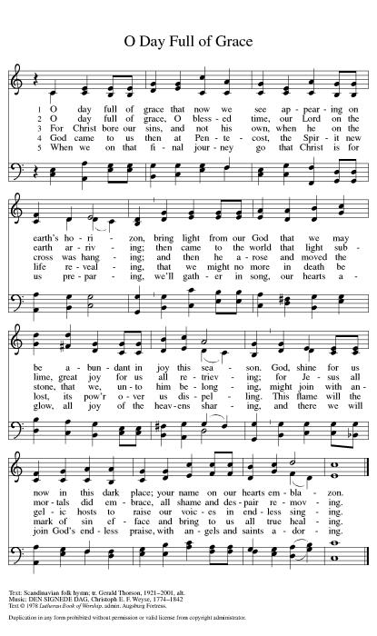
Dismissal (ELW p. 155)
Go in peace. Christ is with you.
Thanks be to God.

From sundaysandseasons.com. Copyright © 2023 Augsburg Fortress. All rights reserved. Hymns available under One License A - 710028.

OFFICIATING & SERVING - MAY 21st
Pastor: Jeremy Ullrich Organist: Debra Caldwell
Pastor Assist: Amanda Harper
Comm Assist: Don Bruggman
Lector: Ronnie Persky
Acolyte: Addison Patterson
Usher Captain: Weldon Kurtz
Ushers: Cedalia Kurtz, Brandon & Debi, Kris, Kody & Courtney Janke
Greeters: Robert & Dorothy Marwitz
Altar Care: Dorothy & Robert Marwitz
Teller Captain: Pam Fleming
Tellers: Deborah Martin and Kristi Dague
OFFICIATING & SERVING - MAY 28th
Pastor: Jeremy Ullrich Organist: Debra Caldwell
Lector: Dorothy Marwitz
Acolyte: James Steglich
Usher Captain: Weldon Kurtz
Ushers: Cedalia Kurtz, Brandon & Debi, Kris, Kody & Courtney Janke
Altar Care: Paula Unberhagen & Pat Stroud
Greeters: Charles Hill & Jimmy Gommert
Teller Captain: Pam Fleming
Tellers: Deborah Martin and Kristi Dague

OFFICIATING & SERVING - June 4th
Pastor: Jeremy Ullrich Organist: Debra Caldwell
Pastor Asst: Weldon Kurtz
Communion Asst: Harold Kurtz
Lector: Shirley Fischer
Acolyte: James Steglich
Usher Captain: Lynn Friedrich
Ushers: Jimmy Gommert, Charles Hill, & David Tschoerner
Greeters: Lenard & Gloria Steglich
Altar Care: Robert & Dorothy Marwitz
Teller Captain: Imogene Morris
Tellers: David Tschoerner & Charles Gersbach

OFFERING & ATTENDANCE
Worship Attendance Offering YTD .
May 7 66 $ 5,322.00 $75,545.87
May 14 52 $ 2,168.00 $77,716.87
FUTURE HAPPENINGS
Wednesday: Men’s Bible Study meets each Wednesday in the TRC @ 7:30 am
Thursday: Piece Makers meet each Thursday in the TRC @ 1:00 pm
IN OUR PRAYERS
Garland Wentrcek Stanley Glaser Melinda Kurtz Pauline Wolbrueck
Celeste Gamrod Holly Naiser(Marie Karl’s daughter)
Janet Rasmussen(Carol Wilson’s friend) Monica Blane(Pastor Daniel Blane”s daughter) Jeff Sparks (friend of Ray and Ruth Janke) Mike Bartek (friend of Alan and Retha Shepherd)
Darrell Kurtz(Twin Brother of Harold Kurtz) Pansy Lange
ANNOUNCEMENTS
Piecemakers Request
The Piecemakers have asked for any sewing, crocheting, knitting, and supplies for sewing quilts. This would include sewing machines, scissors, rotary cutters, fabric, thread, pins and needles or anything that pertains to quilting.

Sunday School
Both the children's and adult's classes begin at 9:15 am.

Theology on Tap
We are having our next Theology on Tap meeting on May 17, 2023 starting at 6:30pm and
lasting until 8:30pm at Judy and Leland Gersbach’s Home. The event is focused on having conversations about faith in a relaxed setting (where alcohol is permitted). Topics will be selected based upon the feedback of those attending. People of all ages are welcome to attend. The discussion topic for the evening is still being decided.

Summer Worship
Summer Heart Hymn Worship Services will begin June 4th at 9:30am.

Pastoral Visits
We are encouraging those hospitalized, nursing home residents (or, their family members), and the homebound members and friends who wish to schedule an in-person pastoral visit or phone call to contact Pastor Jeremy Ullrich @ 979-421-3303 or the church office @ 254-527-3341.
NOTE: Pastor Ullrich will need to be listed as a “visitor of choice” in hospitals or nursing homes. This will need to be established by a family member.

Family Promise
THANK YOU! For April Donations!
Please donate as you are able for families in crisis. Needed items are toilet paper, paper towels, female products, diapers, etc. Also needed are food items like cookies and cake mixes, etc. For further information contact Cedalia Kurtz at 254-657-2588.

Third Thursday Will-O-Bell Nursing Home Worship
Thank you to everyone who has been supporting the residents of our local nursing home! Through communion and a 30-minute hymn sing-along, we are currently the only opportunity that nursing home residents have to worship! Please show these residents they are not forgotten by joining us on the third Thursday of each month at 10AM.

Articles for the Newsletter
Please submit your articles for the monthly newsletter before the 19th of the month, as they are mailed out the following week. Thank you!

Live Stream Learning
St. John has purchased a camcorder to help with our live stream. We are looking for tech-inclined volunteers interested in testing out different settings. We will use an apprenticeship model for training, so you will have a mentor helping as long as you wish. For more information, contact the church office (254-527-3341).

Prayer Requests
When you make a prayer request for a non-member, please provide the church office with contact information so that we can send them a card. Thank you.

Martha’s Circle Bible Study
Women's Bible Study meets the 3rd Tuesday of each month in the TRC @ 2 pm. For more information contact Janice Atchison (254-721-8477).

Flag Donations
3x5 U.S. Flags with grommets are appreciated for our church. In memory of loved ones, you may donate flags, or make cash donations, at the church office. For further information contact Walt Saverse @ 254-770-8381, or contact the church office @ 254-527-3341.

Sisters in Christ Bible Study
The Sisters in Christ Bible study will not be meeting in May. They will meet again on June 17th @ 10am in the TRC and begin “Help is Here” by Max Lucado. If interested in attending, please contact Joey Saverse.

Save the Date
The 140th Anniversary of St. John Lutheran Church is scheduled for December 10, 2023.

Personal Care Kits
Goal 150-200 Kits
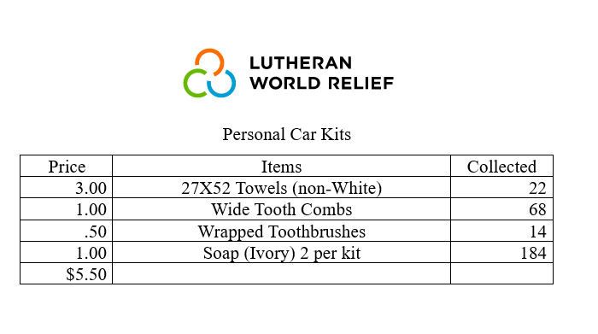
Items are needed between now and September. If you have any questions or concerns, please call Dianne Sager at 512-413-0520. I welcome your help.

Graduation Breakfast
Graduation Breakfast and Recognition for Huston Martin will be May 21 @9:15am in the TRC.

https://stjohnbartlett.breezechms.com/form/24c29c61883931078

