ST. JOHN LUTHERAN CHURCH BARTLETT, TX
ELW Setting Four- Sunday, May 28, 2023
Day of Pentecost

Next Sunday Begins our Summer Schedule - Worship at 9:30am - The
Council voted to remain in the Sanctuary (not the TRC)

Announcements
Prelude
Thanksgiving for Baptism (ELW p. 97)
In the name of the Father,
and of the ☩ Son,
and of the Holy Spirit.
Amen.

Joined to Christ in the waters of baptism,
we are clothed with God's mercy and forgiveness.
Let us give thanks for the gift of baptism.

We give you thanks, O God,
for in the beginning your Spirit moved over the waters
and by your Word you created the world,
calling forth life in which you took delight.

Through the waters of the flood you delivered Noah and his family.
Through the sea you led your people Israel from slavery into freedom.
At the river your Son was baptized by John and anointed with the Holy Spirit.
By water and your Word you claim us as daughters and sons,
making us heirs of your promise and servants of all.

We praise you for the gift of water that sustains life,
and above all we praise you for the gift of new life in Jesus Christ.
Shower us with your Spirit,
and renew our lives with your forgiveness, grace, and love.

To you be given honor and praise
through Jesus Christ our Lord
in the unity of the Holy Spirit, now and forever.
Amen.

Gathering Song - Praise to the Lord God Almighty - ELW Hymn #858
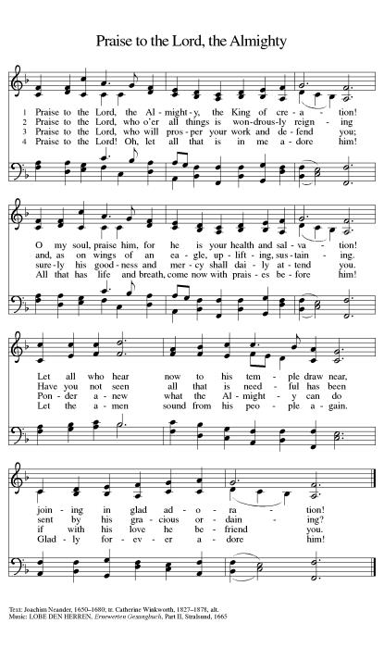

Greeting (ELW p. 147)
The grace of our Lord Jesus Christ, the love of God,
and the communion of the Holy Spirit be with you all.
And also with you.

Kyrie (ELW p. 147)
In peace, let us pray to the Lord.
Lord, have mercy.
For the peace from above, and for our salvation, let us pray to the Lord.
Lord, have mercy.
For the peace of the whole world, for the well-being of the Church of God,
and for the unity of all, let us pray to the Lord.
Lord, have mercy.
For this holy house, and for all who offer here their worship and praise,
let us pray to the Lord.
Lord, have mercy.
Help, save, comfort, and defend us, gracious Lord.
Amen.

Canticle of Praise (ELW p. 148)
Glory to God in the highest,
and peace to God’s people on earth.
Lord God, heavenly King, almighty God and Father,
we worship you, we give you thanks,
we praise you for your glory.
Lord Jesus Christ,
only Son of the Father, Lord God, Lamb of God,
you take away the sin of the world: have mercy on us;
you are seated at the right hand of the Father:
receive our prayer. For you alone are the Holy One,
you alone are the Lord, you alone are the Most High,
Jesus Christ, with the Holy Spirit,
in the glory of God the Father. Amen.

Prayer of the Day (ELW p. 150)
Let us pray.
A brief silence
O God, on this day you open the hearts of your faithful people by sending into us your Holy Spirit. Direct us by the light of that Spirit, that we may have a right judgment in all things and rejoice at all times in your peace, through Jesus Christ, your Son and our Lord, who lives and reigns with you and the Holy Spirit, one God, now and forever.
Amen.

Song - Give Me Jesus - ELW Hymn #770
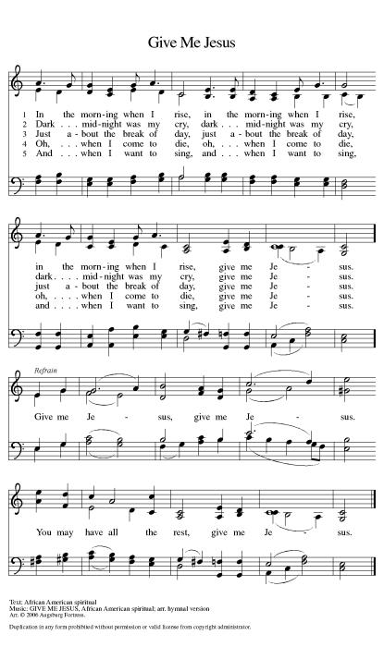

First Reading: Acts 2:1-21
A reading from Acts.
Pentecost was a Jewish harvest festival that marked the fiftieth day after Passover. Luke portrays the Holy Spirit being poured out upon the disciples before the gathered and astonished people assembled in Jerusalem for the festival. Filled with the Spirit, the disciples were able to witness to the power of Christ’s resurrection.
¹When the day of Pentecost had come, [the apostles] were all together in one place. ²And suddenly from heaven there came a sound like the rush of a violent wind, and it filled the entire house where they were sitting. ³Divided tongues, as of fire, appeared among them, and a tongue rested on each of them. ⁴All of them were filled with the Holy Spirit and began to speak in other languages, as the Spirit gave them ability.
⁵Now there were devout Jews from every nation under heaven living in Jerusalem. ⁶And at this sound the crowd gathered and was bewildered, because each one heard them speaking in the native language of each. ⁷Amazed and astonished, they asked, “Are not all these who are speaking Galileans? ⁸And how is it that we hear, each of us, in our own native language? ⁹Parthians, Medes, Elamites, and residents of Mesopotamia, Judea and Cappadocia, Pontus and Asia, ¹⁰Phrygia and Pamphylia, Egypt and the parts of Libya belonging to Cyrene, and visitors from Rome, both Jews and proselytes, ¹¹Cretans and Arabs—in our own languages we hear them speaking about God’s deeds of power.” ¹²All were amazed and perplexed, saying to one another, “What does this mean?” ¹³But others sneered and said, “They are filled with new wine.”
¹⁴But Peter, standing with the eleven, raised his voice and addressed them, “Men of Judea and all who live in Jerusalem, let this be known to you, and listen to what I say. ¹⁵Indeed, these are not drunk, as you suppose, for it is only nine o’clock in the morning. ¹⁶No, this is what was spoken through the prophet Joel:
¹⁷‘In the last days it will be, God declares,
that I will pour out my Spirit upon all flesh,
and your sons and your daughters shall prophesy,
and your young men shall see visions,
and your old men shall dream dreams.
¹⁸Even upon my slaves, both men and women,
in those days I will pour out my Spirit;
and they shall prophesy.
¹⁹And I will show portents in the heaven above
and signs on the earth below,
blood, and fire, and smoky mist.
²⁰The sun shall be turned to darkness
and the moon to blood,
before the coming of the Lord’s great and glorious day.
²¹Then everyone who calls on the name of the Lord shall be saved.’ ”

Word of God, word of life.:
Thanks be to God.

Psalm: Psalm 104:24-34, 35b

Refrain: Send forth your Spirit and renew the face of the earth. (Ps. 104:30)
²⁴How manifold are your | works, O Lord!
In wisdom you have made them all; the earth is full | of your creatures.
²⁵Yonder is the sea, great and wide, with its swarms too man- | y to number,
living things both | small and great.
²⁶There go the ships | to and fro,
and Leviathan, which you made for the | sport of it.
²⁷All of them | look to you
to give them their food | in due season.
R: Send forth your Spirit and renew the face of the earth.
²⁸You give it to them; they | gather it;
you open your hand, and they are filled | with good things.
²⁹When you hide your face, | they are terrified;
when you take away their breath, they die and return | to their dust.
³⁰You send forth your Spirit, and they | are created;
and so you renew the face | of the earth.
³¹May the glory of the Lord en- | dure forever;
O Lord, rejoice in | all your works.
R: Send forth your Spirit and renew the face of the earth.
³²You look at the earth | and it trembles;
you touch the mountains | and they smoke.
³³I will sing to the Lord as long | as I live;
I will praise my God while I | have my being.
³⁴May these words of | mine please God.
I will rejoice | in the Lord.
^{35b}Bless the Lord, | O my soul.
Hal- | lelujah!
R: Send forth your Spirit and renew the face of the earth.
Second Reading: 1 Corinthians 12:3b-13
A reading from 1 Corinthians.
Paul is helping the Corinthians understand the relationship between our God-given unity and Spirit-created diversity. The Spirit creates the unity of faith and gives all Christians diverse gifts for the common benefit of all. We need one another’s diverse spiritual gifts because the same Spirit has given them to each person for the common good.
^{3b}No one can say “Jesus is Lord” except by the Holy Spirit.
⁴Now there are varieties of gifts, but the same Spirit; ⁵and there are varieties of services, but the same Lord; ⁶and there are varieties of activities, but it is the same God who activates all of them in everyone. ⁷To each is given the manifestation of the Spirit for the common good. ⁸To one is given through the Spirit the utterance of wisdom, and to another the utterance of knowledge according to the same Spirit, ⁹to another faith by the same Spirit, to another gifts of healing by the one Spirit, ¹⁰to another the working of miracles, to another prophecy, to another the discernment of spirits, to another various kinds of tongues, to another the interpretation of tongues. ¹¹All these are activated by one and the same Spirit, who allots to each one individually just as the Spirit chooses.
¹²For just as the body is one and has many members, and all the members of the body, though many, are one body, so it is with Christ. ¹³For in the one Spirit we were all baptized into one body—Jews or Greeks, slaves or free—and we were all made to drink of one Spirit.

Word of God, word of life.:
Thanks be to God.

Gospel Acclamation (ELW p. 151)
Alleluia. Lord, to whom shall we go?
You have the words of eternal life.
Alleluia.

Gospel: John 20:19-23
The holy gospel according to John.
Glory to you, O Lord.
The risen Jesus appears to his disciples, offering them a benediction, a commission, and the gift of the Holy Spirit.
¹⁹When it was evening on that day, the first day of the week, and the doors of the house where the disciples had met were locked for fear of the Jews, Jesus came and stood among them and said, “Peace be with you.” ²⁰After he said this, he showed them his hands and his side. Then the disciples rejoiced when they saw the Lord. ²¹Jesus said to them again, “Peace be with you. As the Father has sent me, so I send you.” ²²When he had said this, he breathed on them and said to them, “Receive the Holy Spirit. ²³If you forgive the sins of any, they are forgiven them; if you retain the sins of any, they are retained.”

The gospel of the Lord.
Praise to you, O Christ.

Children’s Sermon (ELW p. 151) - Pastor Jeremy Ullrich
Sermon (ELW p. 151) - Pastor Jeremy Ullrich
Hymn of the Day - Savior, Like a Shepherd Lead Us - ELW Hymn #789
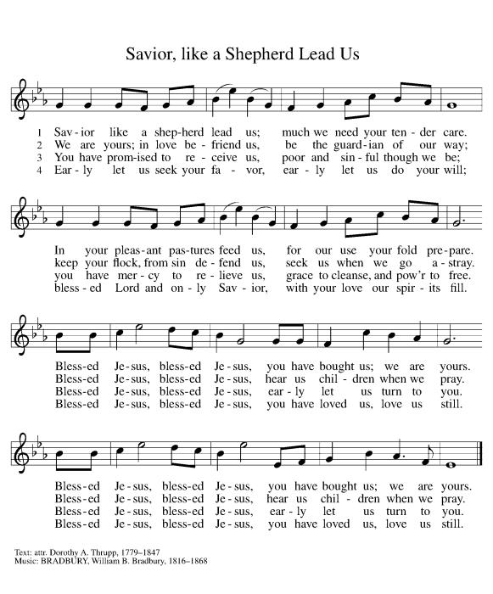

Creed (ELW p. 152)
I believe in God, the Father almighty,
creator of heaven and earth.
I believe in Jesus Christ, God’s only Son, our Lord,
who was conceived by the Holy Spirit,
born of the virgin Mary,
suffered under Pontius Pilate,
was crucified, died, and was buried;
he descended to the dead.*
On the third day he rose again;
he ascended into heaven,
he is seated at the right hand of the Father,
and he will come to judge the living and the dead.
I believe in the Holy Spirit,
the holy catholic church,
the communion of saints,
the forgiveness of sins,
the resurrection of the body,
and the life everlasting. Amen.

Prayers of Intercession
United in the hope and joy of the resurrection, let us pray for the church, the world, and all in need.
A brief silence.
Passionate God, you sent your Spirit through the gifts of fire, wind, and word. As you equipped the disciples for their work, equip us to bring the good news to all those who long for you. Hear us, O God.
Your mercy is great.
Restoring God, wind and flame bring life and destruction throughout the world. We pray for those who work with wind energy, for migratory birds, for protection for lands facing destructive fire, for forestry managers and firefighters. Renew the face of the earth. Hear us, O God.
Your mercy is great.
Ever-present God, your spirit embraces all. Send your spirit of understanding to immigrants, refugees, and any experiencing language barriers. Bless the work of translators, ESL teachers, ambassadors, and international peace organizations. Safely guide those fleeing war and danger. Hear us, O God.
Your mercy is great.
Merciful God, you anoint us with your spirit. Bless nurses, doctors, midwives, chaplains, counselors, and hospice workers as they care for those in need. We pray for all who seek your comfort. Hear us, O God.
Your mercy is great.
Generous God, you impart a variety of gifts. Set aflame the desire to learn from one another, especially those who differ from us. Make your presence known through missionaries, peace workers, and through the outreach ministries of our synod and community. Hear us, O God.
Your mercy is great.
Life-giving God, we give thanks for those who have died to new life in you. As we observe Memorial Day, we remember those who died in military service. Comfort all who mourn, and usher in a world where war is no more. Hear us, O God.
Your mercy is great.
Rejoicing in the victory of Christ’s resurrection, we lift our prayers and praise to you, almighty and eternal God; through Jesus Christ, our risen Lord.
Amen.

Peace (ELW p. 152)
The peace of Christ be with you always.
And also with you.

Offering (ELW p. 152)
Create in me a clean heart, O God,
and renew a right spirit within me.
Cast me not away from your presence,
and take not your Holy Spirit from me.
Restore to me the joy of your salvation,
and uphold me with your free Spirit.

Offering Prayer (ELW p. 152)
Let us pray.
Blessed are you, O God, ruler of heaven and earth. Day by day you shower us with blessings. As you have raised us to new life in Christ, give us glad and generous hearts, ready to praise you and to respond to those in need, through Jesus Christ, our Savior and Lord. Amen.

Lord’s Prayer (ELW p. 154)
Our Father, who art in heaven,
hallowed be thy name,
thy kingdom come,
thy will be done,
on earth as it is in heaven.
Give us this day our daily bread;
and forgive us our trespasses,
as we forgive those
who trespass against us;
and lead us not into temptation,
but deliver us from evil.
For thine is the kingdom,
and the power, and the glory,
forever and ever. Amen.

Blessing (ELW p. 155)
The Lord bless you and keep you.
The Lord’s face shine on you with grace and mercy.
The Lord look upon you with favor and ☩ give you peace.
Amen.

Sending Song - I’m So Glad Jesus Lifted Me - ELW Hymn #860
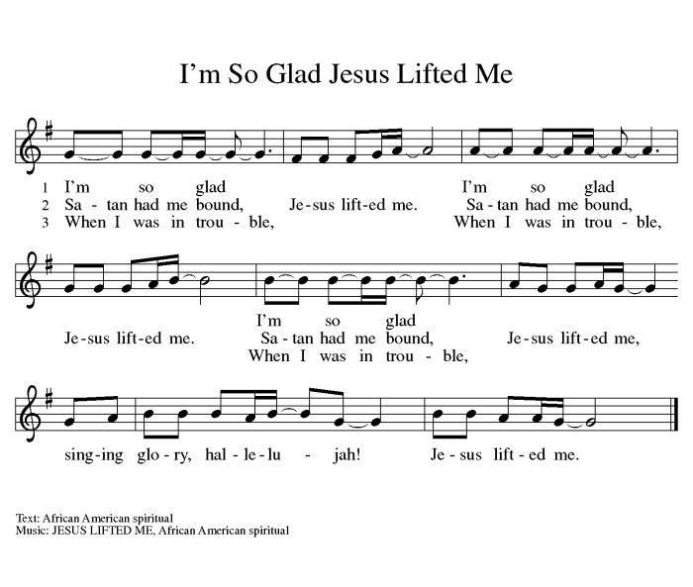

Dismissal (ELW p. 155)
Go in peace. Follow the Spirit.
Thanks be to God.

OFFICIATING & SERVING - MAY 28th
Pastor: Jeremy Ullrich Organist: Debra Caldwell
Lector: Dorothy Marwitz
Acolyte: James Steglich
Usher Captain: Weldon Kurtz
Ushers: Cedalia Kurtz, Brandon & Debi, Kris, Kody & Courtney Janke
Altar Care: Paula Unberhagen & Pat Stroud
Greeters: Charles Hill & Jimmy Gommert
Teller Captain: Pam Fleming
Tellers: Deborah Martin and Kristi Dague
OFFICIATING & SERVING - June 4th
Pastor: Jeremy Ullrich Organist: Debra Caldwell
Pastor Asst: Weldon Kurtz
Communion Asst: Harold Kurtz
Lector: Shirley Fischer
Acolyte: James Steglich
Usher Captain: Lynn Friedrich
Ushers: Jimmy Gommert, Charles Hill, & David Tschoerner
Greeters: Lenard & Gloria Steglich
Altar Care: Robert & Dorothy Marwitz
Teller Captain: Imogene Morris
Tellers: David Tschoerner & Charles Gersbach

OFFICIATING & SERVING - June 11th
Pastor: Jeremy Ullrich Organist: Debra Caldwell
Lector: Carol Wilson
Acolyte: James Steglich
Usher Captain: Lynn Friedrich
Ushers: Jimmy Gommert, Charles Hill, & David Tschoerner
Greeters: Lenard & Gloria Steglich
Altar Care: Robert & Dorothy Marwitz
Teller Captain: Dorothy Marwitz
Tellers: David Tschoerner & Charles Gersbach

OFFERING & ATTENDANCE
Worship Attendance Offering YTD .
May 7 66 $ 5,322.00 $75,545.87
May 14 52 $ 2,168.00 $77,716.87
May21 62 $ 1,878.00 $79,594.87
FUTURE HAPPENINGS
Wednesday: Men’s Bible Study meets each Wednesday in the TRC @ 7:30 am
Thursday: Piece Makers meet each Thursday in the TRC @ 1:00 pm
IN OUR PRAYERS
Garland Wentrcek Stanley Glaser Melinda Kurtz Pauline Wolbrueck
Celeste Gamrod Holly Naiser(Marie Karl’s daughter)
Janet Rasmussen(Carol Wilson’s friend) Monica Blane(Pastor Daniel Blane”s daughter) Jeff Sparks (friend of Ray and Ruth Janke) Mike Bartek (friend of Alan and Retha Shepherd)
Darrell Kurtz(Twin Brother of Harold Kurtz) Pansy Lange
ANNOUNCEMENTS
Piecemakers Request
The Piecemakers have asked for any sewing, crocheting, knitting, and supplies for sewing quilts. This would include sewing machines, scissors, rotary cutters, fabric, thread, pins and needles or anything that pertains to quilting.
Sunday School
Both the children's and adult's classes begin at 9:15 am.

Theology on Tap
We are having our next Theology on Tap meeting on May 17, 2023 starting at 6:30pm and
lasting until 8:30pm at Judy and Leland Gersbach’s Home. The event is focused on having conversations about faith in a relaxed setting (where alcohol is permitted). Topics will be selected based upon the feedback of those attending. People of all ages are welcome to attend. The discussion topic for the evening is still being decided.

Summer Worship
Summer Heart Hymn Worship Services will begin June 4th at 9:30am.

Pastoral Visits
We are encouraging those hospitalized, nursing home residents (or, their family members), and the homebound members and friends who wish to schedule an in-person pastoral visit or phone call to contact Pastor Jeremy Ullrich @ 979-421-3303 or the church office @ 254-527-3341.
NOTE: Pastor Ullrich will need to be listed as a “visitor of choice” in hospitals or nursing homes. This will need to be established by a family member.

Family Promise
THANK YOU! For April Donations!
Please donate as you are able for families in crisis. Needed items are toilet paper, paper towels, female products, diapers, etc. Also needed are food items like cookies and cake mixes, etc. For further information contact Cedalia Kurtz at 254-657-2588.

Third Thursday Will-O-Bell Nursing Home Worship
Thank you to everyone who has been supporting the residents of our local nursing home! Through communion and a 30-minute hymn sing-along, we are currently the only opportunity that nursing home residents have to worship! Please show these residents they are not forgotten by joining us on the third Thursday of each month at 10AM.

Articles for the Newsletter
Please submit your articles for the monthly newsletter before the 19th of the month, as they are mailed out the following week. Thank you!

Live Stream Learning
St. John has purchased a camcorder to help with our live stream. We are looking for tech-inclined volunteers interested in testing out different settings. We will use an apprenticeship model for training, so you will have a mentor helping as long as you wish. For more information, contact the church office (254-527-3341).

Prayer Requests
When you make a prayer request for a non-member, please provide the church office with contact information so that we can send them a card. Thank you.

Martha’s Circle Bible Study
Women's Bible Study meets the 3rd Tuesday of each month in the TRC @ 2 pm. For more information contact Janice Atchison (254-721-8477).

Flag Donations
3x5 U.S. Flags with grommets are appreciated for our church. In memory of loved ones, you may donate flags, or make cash donations, at the church office. For further information contact Walt Saverse @ 254-770-8381, or contact the church office @ 254-527-3341.

Sisters in Christ Bible Study
The Sisters in Christ Bible study will not be meeting in May. They will meet again on June 17th @ 10am in the TRC and begin “Help is Here” by Max Lucado. If interested in attending, please contact Joey Saverse.

Save the Date
The 140th Anniversary of St. John Lutheran Church is scheduled for December 10, 2023.

Personal Care Kits
Goal 150-200 Kits
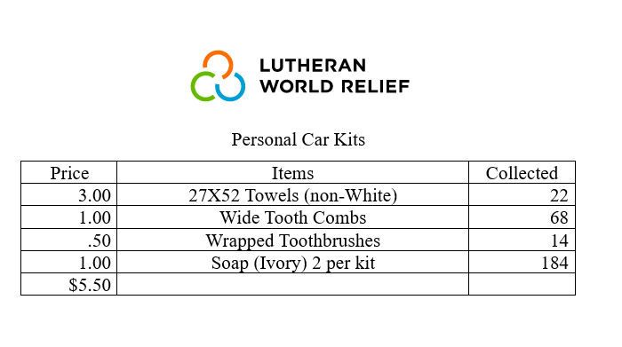
Items are needed between now and September. If you have any questions or concerns, please call Dianne Sager at 512-413-0520. I welcome your help.

https://stjohnbartlett.breezechms.com/form/24c29c61883931078

