ST. JOHN LUTHERAN CHURCH BARTLETT,TX
ELW Holy Communion - Sunday, June 4, 2023
Holy Trinity Sunday

Announcements
Prelude
Confession and Forgiveness (ELW p. 94)
In the name of the Father,
and of the ☩ Son,
and of the Holy Spirit.
Amen.
God of all mercy and consolation, come to the help of your people, turning us from our sin to live for you alone. Give us the power of your Holy Spirit that we may confess our sin, receive your forgiveness, and grow into the fullness of Jesus Christ, our Savior and Lord.
Amen.
Let us confess our sin in the presence of God and of one another.
Most merciful God,
we confess that we are captive to sin and cannot free ourselves. We have sinned against you in thought, word, and deed, by what we have done and by what we have left undone. We have not loved you with our whole heart; we have not loved our neighbors as ourselves. For the sake of your Son, Jesus Christ, have mercy on us. Forgive us, renew us, and lead us, so that we may delight in your will and walk in your ways, to the glory of your holy name.
Amen.
In the mercy of almighty God, Jesus Christ was given to die for us, and for his sake God forgives us all our sins. As a called and ordained minister of the church of Christ, and by his authority, I therefore declare to you the entire forgiveness of all your sins, in the name of the Father, and of the ☩ Son, and of the Holy Spirit.
Amen.

Gathering Song - Holy, Holy, Holy - ELW Hymn #413
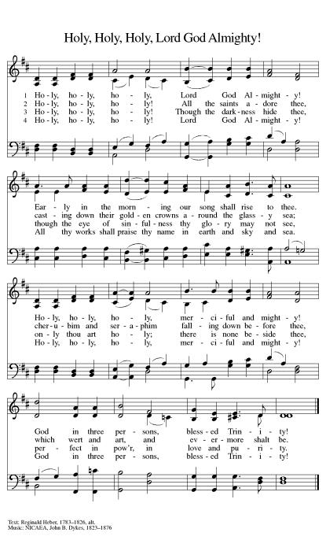

Greeting (ELW p. 147)
The grace of our Lord Jesus Christ, the love of God,
and the communion of the Holy Spirit be with you all.
And also with you.

Kyrie (ELW p. 147)
In peace, let us pray to the Lord.
Lord, have mercy.
For the peace from above, and for our salvation, let us pray to the Lord.
Lord, have mercy.
For the peace of the whole world, for the well-being of the Church of God,
and for the unity of all, let us pray to the Lord.
Lord, have mercy.
For this holy house, and for all who offer here their worship and praise,
let us pray to the Lord.
Lord, have mercy.
Help, save, comfort, and defend us, gracious Lord.
Amen.

Canticle of Praise (ELW p. 148)
This is the feast of victory for our God. Alleluia.
Worthy is Christ, the Lamb who was slain,
whose blood set us free to be people of God.
Power and riches and wisdom and strength,
and honor and blessing and glory are his.
This is the feast of victory for our God. Alleluia.
Sing with all the people of God
and join in the hymn of all creation:
Blessing and honor and glory and might
be to God and the Lamb forever. Amen.
This is the feast of victory for our God,
for the Lamb who was slain has begun his reign.
Alleluia. Alleluia.

Prayer of the Day (ELW p. 150)
Let us pray.
Almighty Creator and ever-living God: we worship your glory, eternal Three-in-One, and we praise your power, majestic One-in-Three. Keep us steadfast in this faith, defend us in all adversity, and bring us at last into your presence, where you live in endless joy and love, Father, Son, and Holy Spirit, one God, now and forever. Amen.

Song - Blessed Assurance - ELW Hymn #638
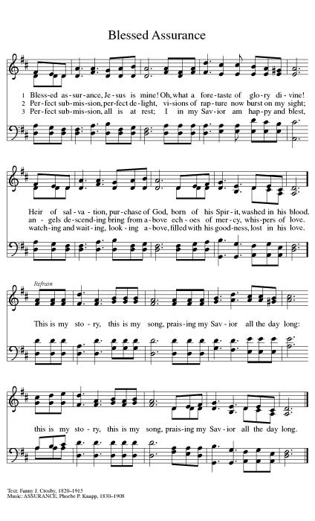

First Reading: Genesis 1:1--2:4a
A reading from Genesis.
At the beginning of time, God the Creator, God the powerful Word, and God the life-giving Spirit form the earth and all its inhabitants. God sees that all this created work is good and then rests on the seventh day.
¹In the beginning when God created the heavens and the earth, ²the earth was a formless void and darkness covered the face of the deep, while a wind from God swept over the face of the waters. ³Then God said, “Let there be light”; and there was light. ⁴And God saw that the light was good; and God separated the light from the darkness. ⁵God called the light Day, and the darkness he called Night. And there was evening and there was morning, the first day.
⁶And God said, “Let there be a dome in the midst of the waters, and let it separate the waters from the waters.” ⁷So God made the dome and separated the waters that were under the dome from the waters that were above the dome. And it was so. ⁸God called the dome Sky. And there was evening and there was morning, the second day.
⁹And God said, “Let the waters under the sky be gathered together into one place, and let the dry land appear.” And it was so. ¹⁰God called the dry land Earth, and the waters that were gathered together he called Seas. And God saw that it was good. ¹¹Then God said, “Let the earth put forth vegetation: plants yielding seed, and fruit trees of every kind on earth that bear fruit with the seed in it.” And it was so. ¹²The earth brought forth vegetation: plants yielding seed of every kind, and trees of every kind bearing fruit with the seed in it. And God saw that it was good. ¹³And there was evening and there was morning, the third day.
¹⁴And God said, “Let there be lights in the dome of the sky to separate the day from the night; and let them be for signs and for seasons and for days and years, ¹⁵and let them be lights in the dome of the sky to give light upon the earth.” And it was so. ¹⁶God made the two great lights—the greater light to rule the day and the lesser light to rule the night—and the stars. ¹⁷God set them in the dome of the sky to give light upon the earth, ¹⁸to rule over the day and over the night, and to separate the light from the darkness. And God saw that it was good. ¹⁹And there was evening and there was morning, the fourth day.
²⁰And God said, “Let the waters bring forth swarms of living creatures, and let birds fly above the earth across the dome of the sky.” ²¹So God created the great sea monsters and every living creature that moves, of every kind, with which the waters swarm, and every winged bird of every kind. And God saw that it was good. ²²God blessed them, saying, “Be fruitful and multiply and fill the waters in the seas, and let birds multiply on the earth.” ²³And there was evening and there was morning, the fifth day.
²⁴And God said, “Let the earth bring forth living creatures of every kind: cattle and creeping things and wild animals of the earth of every kind.” And it was so. ²⁵God made the wild animals of the earth of every kind, and the cattle of every kind, and everything that creeps upon the ground of every kind. And God saw that it was good.
²⁶Then God said, “Let us make humankind in our image, according to our likeness; and let them have dominion over the fish of the sea, and over the birds of the air, and over the cattle, and over all the wild animals of the earth, and over every creeping thing that creeps upon the earth.”
²⁷So God created humankind in his image,
in the image of God he created them;
male and female he created them.
²⁸God blessed them, and God said to them, “Be fruitful and multiply, and fill the earth and subdue it; and have dominion over the fish of the sea and over the birds of the air and over every living thing that moves upon the earth.” ²⁹God said, “See, I have given you every plant yielding seed that is upon the face of all the earth, and every tree with seed in its fruit; you shall have them for food. ³⁰And to every beast of the earth, and to every bird of the air, and to everything that creeps on the earth, everything that has the breath of life, I have given every green plant for food.” And it was so. ³¹God saw everything that he had made, and indeed, it was very good. And there was evening and there was morning, the sixth day.
^{2:1}Thus the heavens and the earth were finished, and all their multitude. ²And on the seventh day God finished the work that he had done, and he rested on the seventh day from all the work that he had done. ³So God blessed the seventh day and hallowed it, because on it God rested from all the work that he had done in creation.
^{4a}These are the generations of the heavens and the earth when they were created.

The word of the Lord.
Thanks be to God.

Psalm: Psalm 8
Refrain: How majestic is your name in all the earth! (Ps. 8:1)
¹O | Lord our Lord,
how majestic is your name in | all the earth!—
²you whose glory is chanted above the heavens out of the mouths of in- | fants and children;
you have set up a fortress against your enemies, to silence the foe | and avenger.
³When I consider your heavens, the work | of your fingers,
the moon and the stars you have set | in their courses,
⁴what are mere mortals that you should be mind- | ful of them,
human beings that you should | care for them?
R: How majestic is your name in all the earth!
⁵Yet you have made them little less | than divine;
with glory and hon- | or you crown them.
⁶You have made them rule over the works | of your hands;
you have put all things un- | der their feet:
⁷all | flocks and cattle,
even the wild beasts | of the field,
⁸the birds of the air, the fish | of the sea,
and whatever passes along the paths | of the sea.
⁹O | Lord our Lord,
how majestic is your name in | all the earth!
R: How majestic is your name in all the earth!

Second Reading: 2 Corinthians 13:11-13
A reading from 2 Corinthians.
Paul closes a challenging letter to the Corinthians with an appeal to Christian fellowship grounded in the triune harmony of Christ’s grace, God’s love, and the Spirit’s partnership.
[Paul writes:] ¹¹Finally, brothers and sisters, farewell. Put things in order, listen to my appeal, agree with one another, live in peace; and the God of love and peace will be with you. ¹²Greet one another with a holy kiss. All the saints greet you.
¹³The grace of the Lord Jesus Christ, the love of God, and the communion of the Holy Spirit be with all of you.

The word of the Lord.
Thanks be to God.

Gospel Acclamation (ELW p. 151)

Alleluia. Lord, to whom shall we go?
You have the words of eternal life.
Alleluia.

Gospel: Matthew 28:16-20
The holy gospel according to Matthew.
Glory to you, O Lord.
After his resurrection, Jesus summons his remaining disciples and commissions them to baptize and teach all nations in the name of the Father, Son, and Holy Spirit.
¹⁶Now the eleven disciples went to Galilee, to the mountain to which Jesus had directed them. ¹⁷When they saw him, they worshiped him; but some doubted. ¹⁸And Jesus came and said to them, “All authority in heaven and on earth has been given to me. ¹⁹Go therefore and make disciples of all nations, baptizing them in the name of the Father and of the Son and of the Holy Spirit, ²⁰and teaching them to obey everything that I have commanded you. And remember, I am with you always, to the end of the age.”

The gospel of the Lord.
Praise to you, O Christ.

Children’s Sermon (ELW p. 151) - Pastor Jeremy Ullrich
Sermon (ELW p. 151) - Pastor Jeremy Ullrich
Hymn of the Day -This Little Light of Mine - ELW Hymn #677
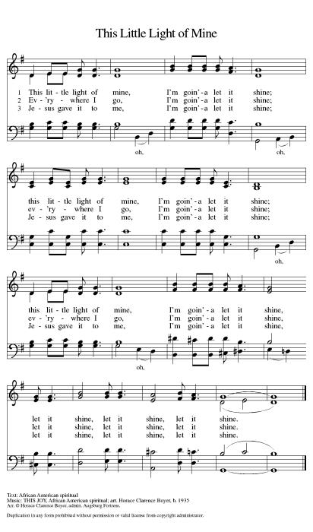

Creed (ELW p. 152)
We believe in one God,
the Father, the Almighty,
maker of heaven and earth,
of all that is, seen and unseen.
We believe in one Lord, Jesus Christ,
the only Son of God,
eternally begotten of the Father,
God from God, Light from Light,
true God from true God,
begotten, not made,
of one Being with the Father;
through him all things were made.
For us and for our salvation
he came down from heaven,
was incarnate of the Holy Spirit and the virgin Mary
and became truly human.
For our sake he was crucified under Pontius Pilate;
he suffered death and was buried.
On the third day he rose again
in accordance with the scriptures;
he ascended into heaven
and is seated at the right hand of the Father.
He will come again in glory to judge the living and the dead,
and his kingdom will have no end.
We believe in the Holy Spirit, the Lord, the giver of life,
who proceeds from the Father and the Son,*
who with the Father and the Son is worshiped and glorified,
who has spoken through the prophets.
We believe in one holy catholic and apostolic church.
We acknowledge one baptism for the forgiveness of sins.
We look for the resurrection of the dead,
and the life of the world to come. Amen.

*Or, “who proceeds from the Father.” The phrase “and the Son” is a later addition to the creed.

Prayers of Intercession
Trusting in God’s abundant mercy, let us offer our prayers for a world in need.
A brief silence.
Holy three, holy one, you call the church to make disciples of all nations. Encourage bishops, pastors, and deacons in their proclamation of the gospel and direct all the baptized into lives of humble service. God, in your mercy,
hear our prayer.
Holy three, holy one, you spoke creation into being and called it good. Protect lands and waters threatened by human misuse and sustain living creatures of every kind: wild animals, birds, fish, and every creeping thing. God, in your mercy,
hear our prayer.
Holy three, holy one, you have given humankind authority over the earth. Raise up leaders who listen earnestly, speak honestly, and govern thoughtfully. Heal divisions between nations, that we might agree with one another and live in peace. God, in your mercy,
hear our prayer.
Holy three, holy one, you promise to be with us always, to the end of the age. Surround those most in need of your healing presence: any who are lonely, all who are grieving, and those who are sick. God, in your mercy,
hear our prayer.
Holy three, holy one, you set the earth on its axis, and we experience the seasons. Strengthen those enduring challenges this summer: those who suffer in the heat, parents overwhelmed by childcare responsibilities, and children experiencing food insecurity outside of school. God, in your mercy,
hear our prayer.
Holy three, holy one, you give rest when our work is done. We give thanks for all the saints who now rest in you, confident in the promise of resurrection life in the age to come. God, in your mercy,
hear our prayer.
Receive our prayers and answer us, O God, in the name of Jesus Christ.
Amen.

Peace (ELW p. 152)
The peace of Christ be with you always.
And also with you.

Offering (ELW p. 152)

Let the vineyards be fruitful, Lord,
and fill to the brim our cup of blessing.
Gather a harvest from the seeds that were sown,
that we may be fed with the bread of life.
Gather the hopes and the dreams of all;
unite them with the prayers we offer now.
Grace our table with your presence,
and give us a foretaste of the feast to come.

Offering Prayer (ELW p. 152)
Let us pray.
Holy God, gracious and merciful, you bring forth food from the earth and nourish your whole creation. Turn our hearts toward those who hunger in any way, that all may know your care; and prepare us now to feast on the bread of life, Jesus Christ, our Savior and Lord. Amen.

Dialogue (ELW p. 152)
The Lord be with you.
And also with you.
Lift up your hearts.
We lift them to the Lord.
Let us give thanks to the Lord our God.
It is right to give our thanks and praise.

Preface (ELW p. 153)
It is indeed right, our duty and our joy,
that we should at all times and in all places
give thanks and praise to you, almighty and merciful God.
You reveal your glory
as the glory of the Father, the Son, and the Holy Spirit:
equal in majesty, undivided in splendor, one Lord, one God,
ever to be adored in your eternal glory.
And so, with all the choirs of angels,
with the church on earth and the hosts of heaven,
we praise your name and join their unending hymn:

Holy, Holy, Holy (ELW p. 153)

Holy, holy, holy Lord,
Lord God of pow’r and might:
Heav’n and earth are full of your glory.
Hosanna in the highest.
Blessed is he who comes in the name of the Lord.
Hosanna in the highest.

Words of Institution (ELW p. 153)
You are indeed holy, almighty and merciful God.
You are most holy,
and great is the majesty of your glory.

You so loved the world that you gave your only Son,
so that everyone who believes in him may not perish
but have eternal life.

We give you thanks for his coming into the world
to fulfill for us your holy will
and to accomplish all things for our salvation.

In the night in which he was betrayed,
our Lord Jesus took bread, and gave thanks;
broke it, and gave it to his disciples, saying:
Take and eat; this is my body, given for you.
Do this for the remembrance of me.

Again, after supper, he took the cup, gave thanks,
and gave it for all to drink, saying:
This cup is the new covenant in my blood,
shed for you and for all people for the forgiveness of sin.
Do this for the remembrance of me.

Lord’s Prayer (ELW p. 154)
Lord, remember us in your kingdom and teach us to pray.
Our Father, who art in heaven,
hallowed be thy name,
thy kingdom come,
thy will be done,
on earth as it is in heaven.
Give us this day our daily bread;
and forgive us our trespasses,
as we forgive those
who trespass against us;
and lead us not into temptation,
but deliver us from evil.
For thine is the kingdom,
and the power, and the glory,
forever and ever. Amen.

Invitation to Communion (ELW p. 154)
Taste and see that the Lord is good.

Communion (ELW p. 154)

Lamb of God, you take away the sin of the world;
have mercy on us.
Lamb of God, you take away the sin of the world;
have mercy on us.
Lamb of God, you take away the sin of the world;
grant us peace, grant us peace.
Communion Hymn - Blest Be the Tie That Binds - ELW Hymn #656

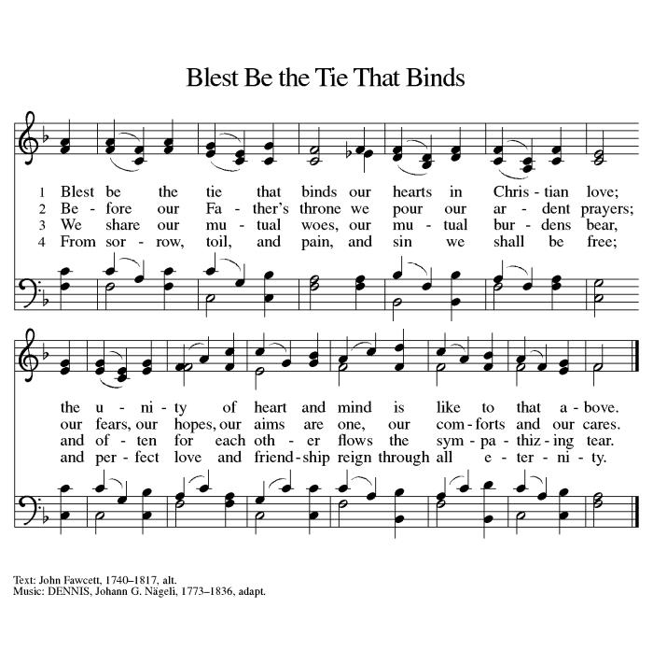

Prayer after Communion (ELW p. 155)
Let us pray.
We give you thanks, almighty God, that you have refreshed us through the healing power of this gift of life. In your mercy, strengthen us through this gift, in faith toward you and in fervent love toward one another; for the sake of Jesus Christ our Lord. Amen.

Blessing (ELW p. 155)
Almighty Trinity, Father, ☩ Son, and Holy Spirit, bless you now and forever.
Amen.

Sending Song - On Our Way Rejoicing - ELW Hymn #537
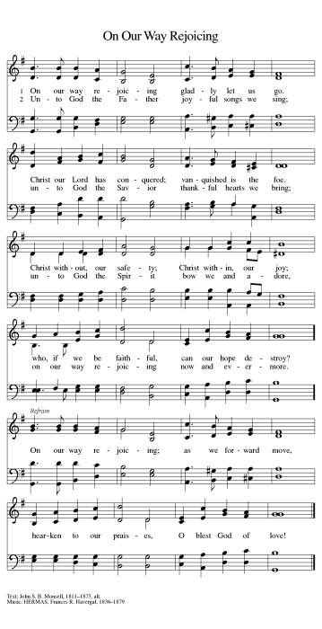

Dismissal (ELW p. 155)
Go in peace. Dwell with the Trinity.
Thanks be to God.
From sundaysandseasons.com. Copyright © 2023 Augsburg Fortress. All rights reserved. Hymns available under One License A - 710028.
OFFICIATING & SERVING - June 4th
Pastor: Jeremy Ullrich Organist: Debra Caldwell
Pastor Asst: Weldon Kurtz
Communion Asst: Harold Kurtz
Lector: Shirley Fischer
Acolyte: James Steglich
Usher Captain: Lynn Friedrich
Ushers: Jimmy Gommert, Charles Hill, & David Tschoerner
Greeters: Lenard & Gloria Steglich
Altar Care: Robert & Dorothy Marwitz
Teller Captain: Imogene Morris
Tellers: David Tschoerner & Charles Gersbach
OFFICIATING & SERVING - June 11th
Pastor: Jeremy Ullrich Organist: Debra Caldwell
Lector: Carol Wilson
Acolyte: James Steglich
Usher Captain: Lynn Friedrich
Ushers: Jimmy Gommert, Charles Hill, & David Tschoerner
Greeters: Lenard & Gloria Steglich
Altar Care: Robert & Dorothy Marwitz
Teller Captain: Dorothy Marwitz
Tellers: David Tschoerner & Charles Gersbach

OFFICIATING & SERVING - June 18th
Pastor: Jeremy Ullrich Organist: Debra Caldwell
Pastor Asst: Wayne Zieschang
Communion Asst: Ronnie Persky
Lector: Michael Kurtz
Acolyte: Andrew Cosper
Usher Captain: Tim Steglich
Ushers: Justin Young, Michael, Joey & Travis Saverse
Greeters: Ted & Dianne Sager
Altar Care: Debi & Courtney Janke
Teller Captain: Dorothy Marwitz
Tellers: Cedalia Kurtz & Mila Wegner

OFFERING & ATTENDANCE
Worship Attendance Offering YTD .
May 7 66 $ 5,322.00 $75,545.87
May 14 52 $ 2,168.00 $77,716.87
May 21 62 $ 1,878.00 $79,594.87
May 28 70 $ 8,386.00 $87,980.87
FUTURE HAPPENINGS
Wednesday: Men’s Bible Study meets each Wednesday in the TRC @ 7:30 am
Thursday: Piece Makers meet each Thursday in the TRC @ 1:00 pm
IN OUR PRAYERS
Garland Wentrcek Stanley Glaser Melinda Kurtz Pauline Wolbrueck
Celeste Gamrod Holly Naiser(Marie Karl’s daughter)
Janet Rasmussen(Carol Wilson’s friend) Monica Blane(Pastor Daniel Blane”s daughter) Jeff Sparks (friend of Ray and Ruth Janke) Mike Bartek (friend of Alan and Retha Shepherd)
Darrell Kurtz(Twin Brother of Harold Kurtz) Pansy Lange
ANNOUNCEMENTS
Piecemakers Request
The Piecemakers have asked for any sewing, crocheting, knitting, and supplies for sewing quilts. This would include sewing machines, scissors, rotary cutters, fabric, thread, pins and needles or anything that pertains to quilting.
Sunday School
Both the children's and adult's classes will take a break for the summer. Adult Sunday School will resume on September the 3rd.

Articles for the Newsletter
Please submit your articles for the monthly newsletter before the 19th of the month, as they are mailed out the following week. Thank you!
Theology on Tap
We are having our next Theology on Tap meeting on June 14 starting at 6:30pm and
lasting until 8:30pm at Dorothy and Robert Marwitz’s Home. The event is focused on having conversations about faith in a relaxed setting (where alcohol is permitted). Topics will be elected based upon the feedback of those attending. People of all ages are welcome to attend. The discussion topic for the evening is still being decided.

Pastoral Visits
We are encouraging those hospitalized, nursing home residents (or, their family members), and the homebound members and friends who wish to schedule an in-person pastoral visit or phone call to contact Pastor Jeremy Ullrich @ 979-421-3303 or the church office @ 254-527-3341.
NOTE: Pastor Ullrich will need to be listed as a “visitor of choice” in hospitals or nursing homes. This will need to be established by a family member.

Family Promise
Please donate as you are able for families in crisis. Needed items are toilet paper, paper towels, female products, diapers, etc. Also needed are food items like cookies and cake mixes, etc. For further information contact Cedalia Kurtz at 254-657-2588.

Third Thursday Will-O-Bell Nursing Home Worship
Thank you to everyone who has been supporting the residents of our local nursing home! Through communion and a 30-minute hymn sing-along, we are currently the only opportunity that nursing home residents have to worship! Please show these residents they are not forgotten by joining us on the third Thursday of each month at 10AM.

Live Stream Learning
St. John has purchased a camcorder to help with our live stream. We are looking for tech-inclined volunteers interested in testing out different settings. We will use an apprenticeship model for training, so you will have a mentor helping as long as you wish. For more information, contact the church office (254-527-3341).

Prayer Requests
When you make a prayer request for a non-member, please provide the church office with contact information so that we can send them a card. Thank you.

Martha’s Circle Bible Study
Women's Bible Study meets the 3rd Tuesday of each month in the TRC @ 2 pm. For more information contact Janice Atchison (254-721-8477).

Flag Donations
3x5 U.S. Flags with grommets are appreciated for our church. In memory of loved ones, you may donate flags, or make cash donations, at the church office. For further information contact Walt Saverse @ 254-770-8381, or contact the church office @ 254-527-3341.

Sisters in Christ Bible Study
The Sisters in Christ Bible study will not be meeting in May. They will meet again on June 17th @ 10am in the TRC and begin “Help is Here” by Max Lucado. If interested in attending, please contact Joey Saverse.

Save the Date
The 140th Anniversary of St. John Lutheran Church is scheduled for December 10, 2023.
P

Personal Care Kits
Updated 5/30/2023
